vOS Virtual Reality Experimental Interface
Live Demo at vos.jit.su, Source code at github.com/GavinOvsak/vOS

vOS started with a question:
What is the richest interface for programs designed for an immersive heads up display?
Game pads and gesture interfaces are bad at text input and fine control, keyboards are difficult to use when you can’t see your hands.
vOS Controller Streaming Input Design:
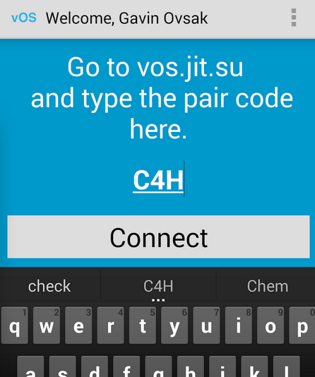
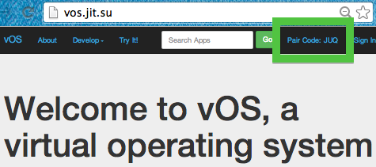
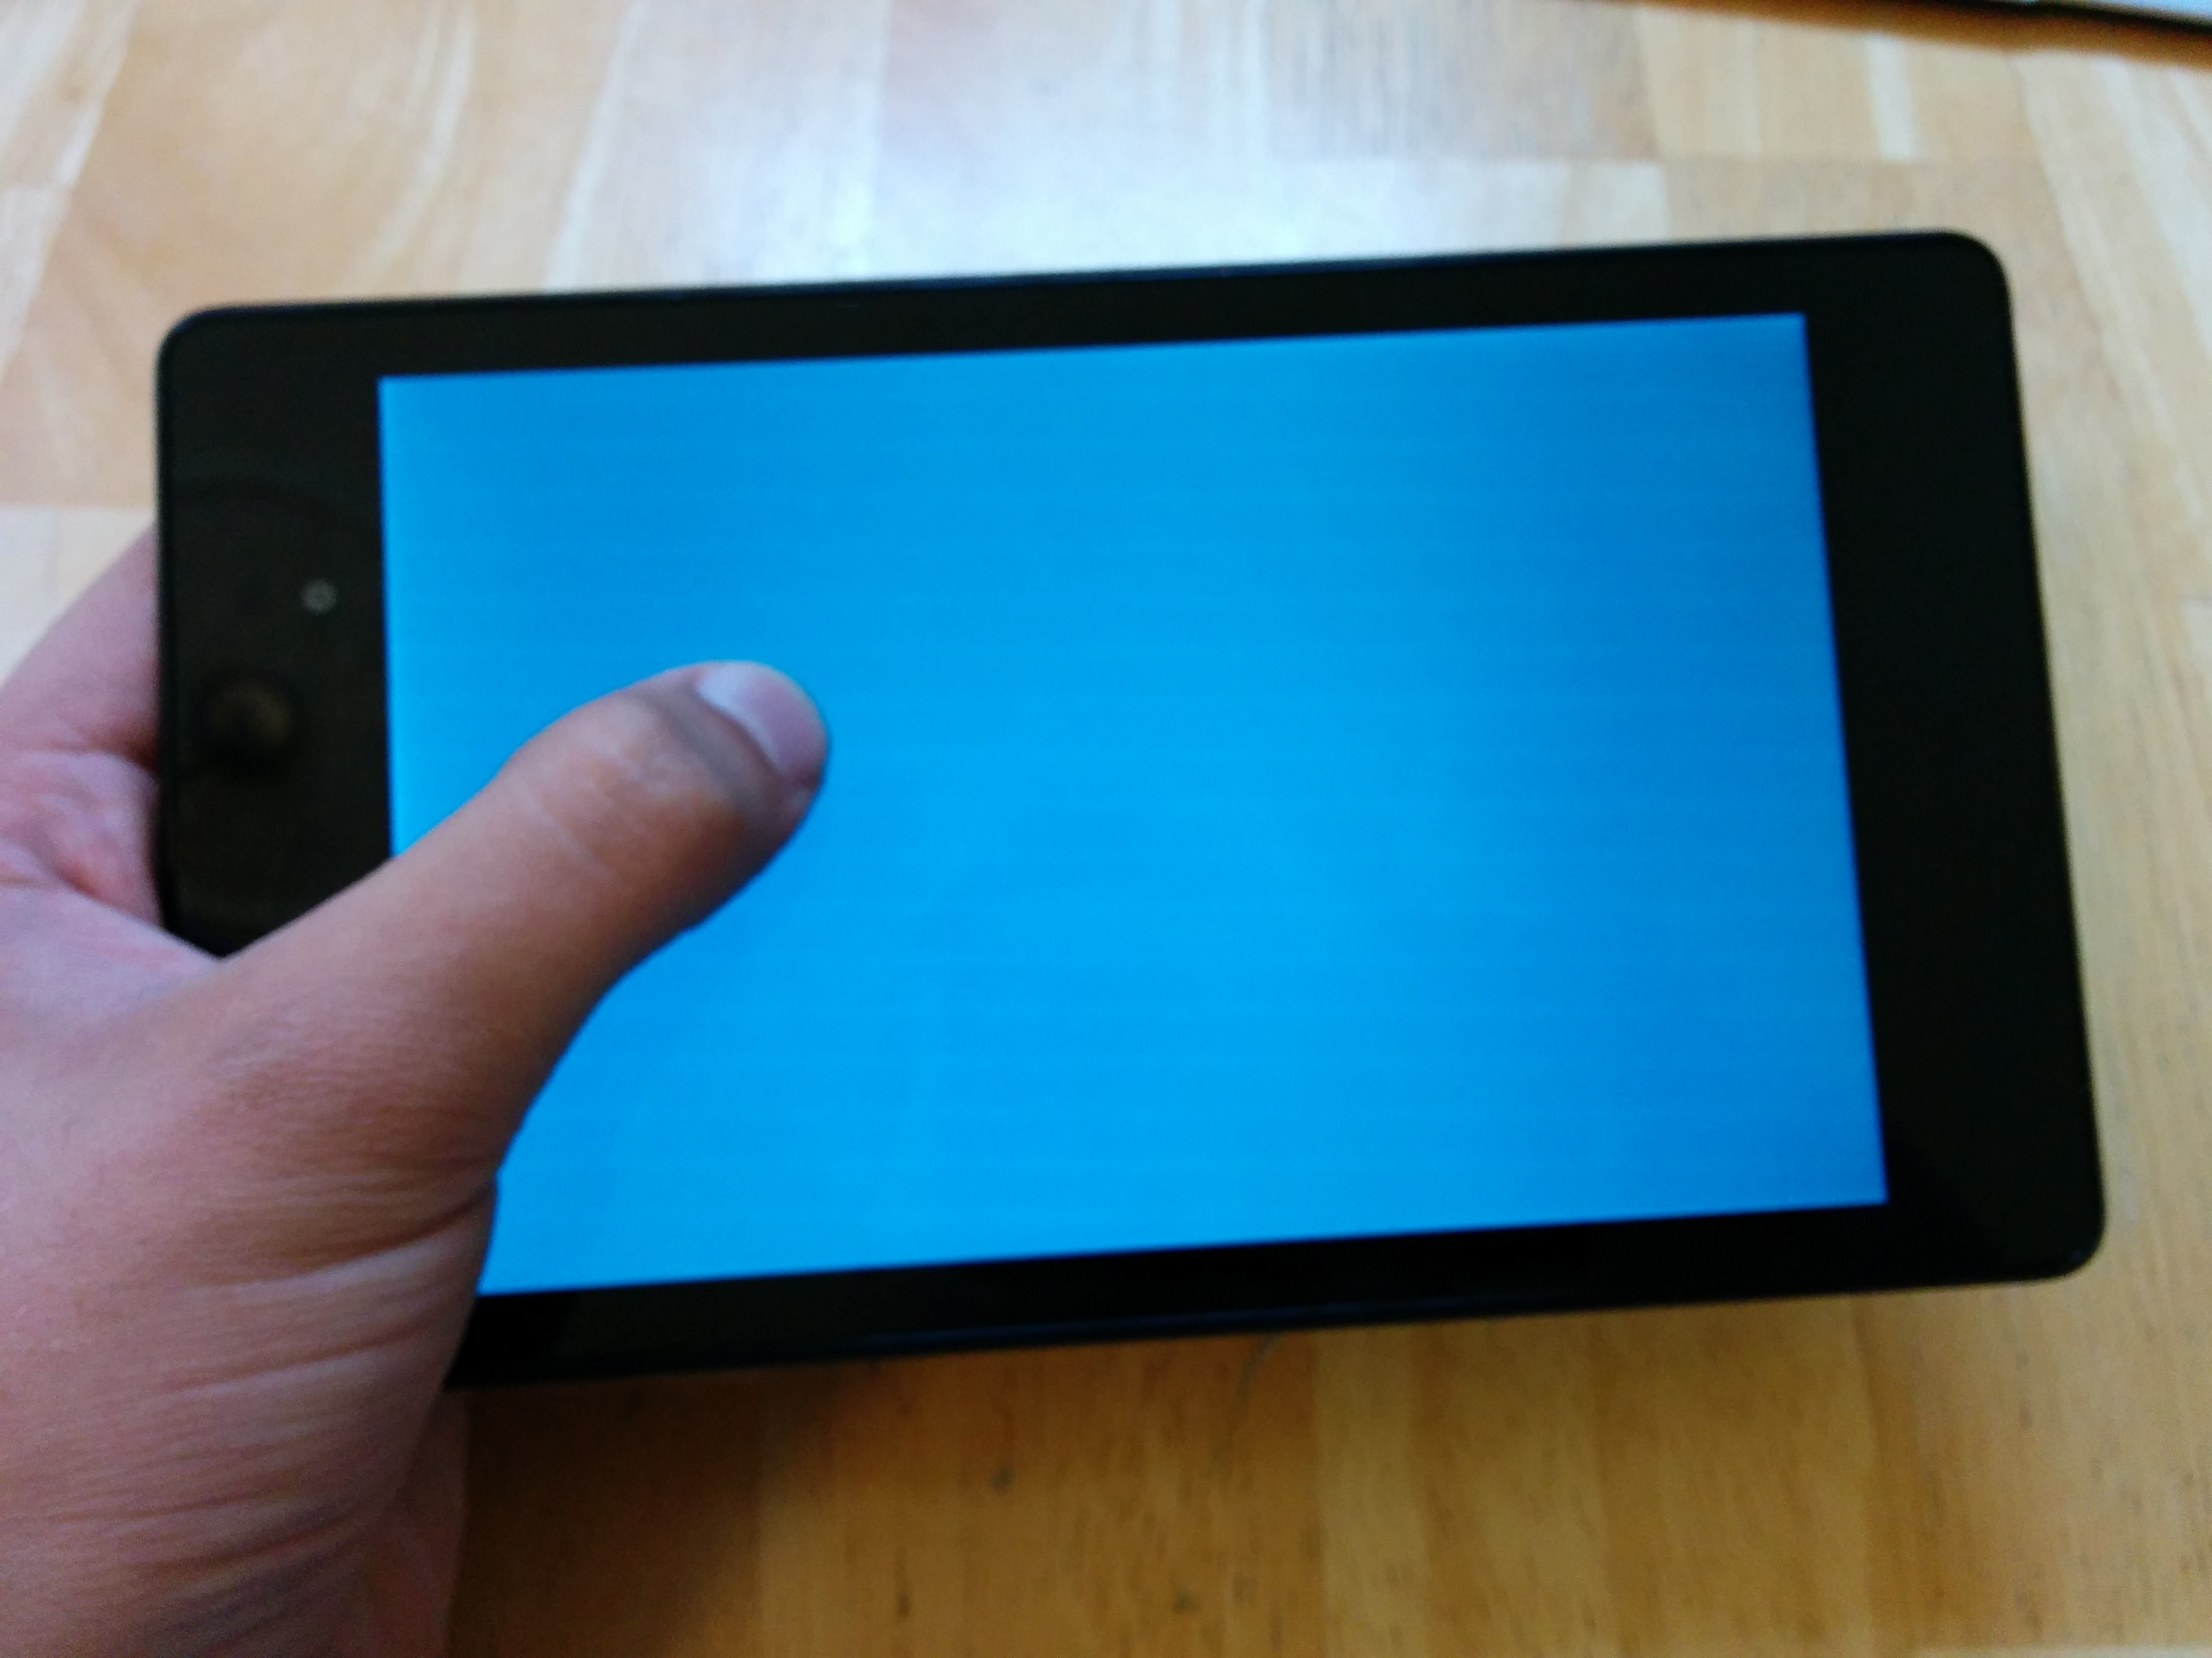
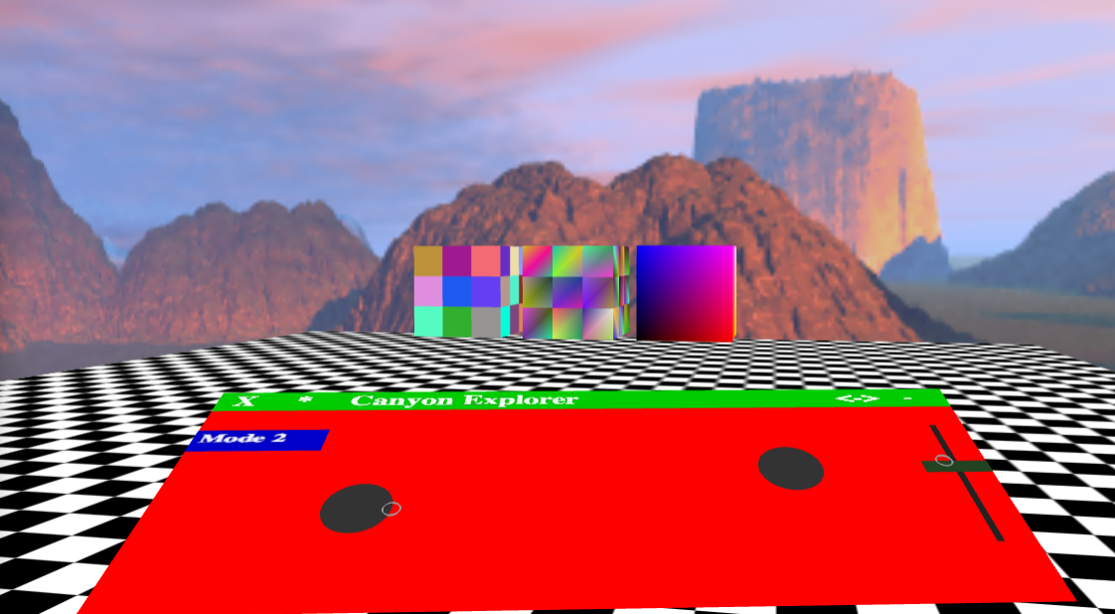

Web Sockets + WebGL

vOS has become an experimental web platform with the purpose of
discovering the full potential of immersive interfaces.
Features:
Designed for multitasking

Platform abstracts away input processing.

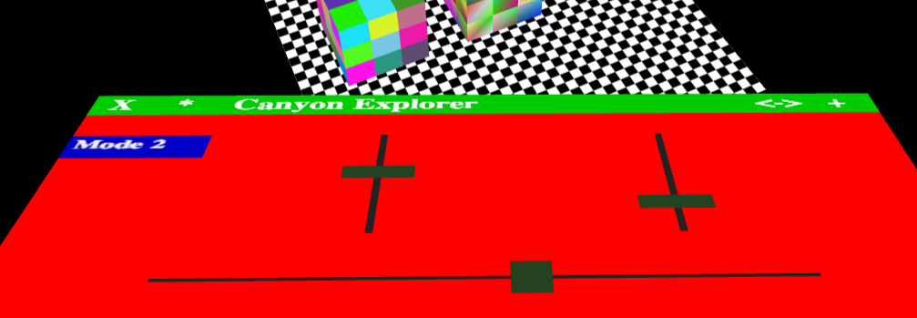
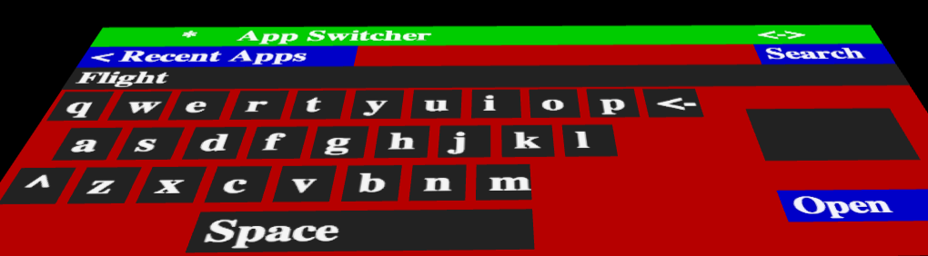
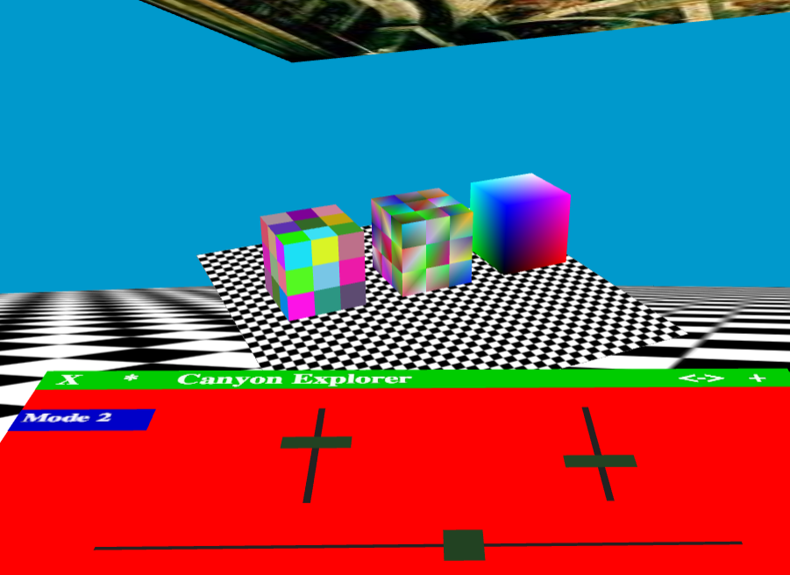
Apps can be viewed in Contained or Immersive mode.

Can view Contained App with Immersive app in background

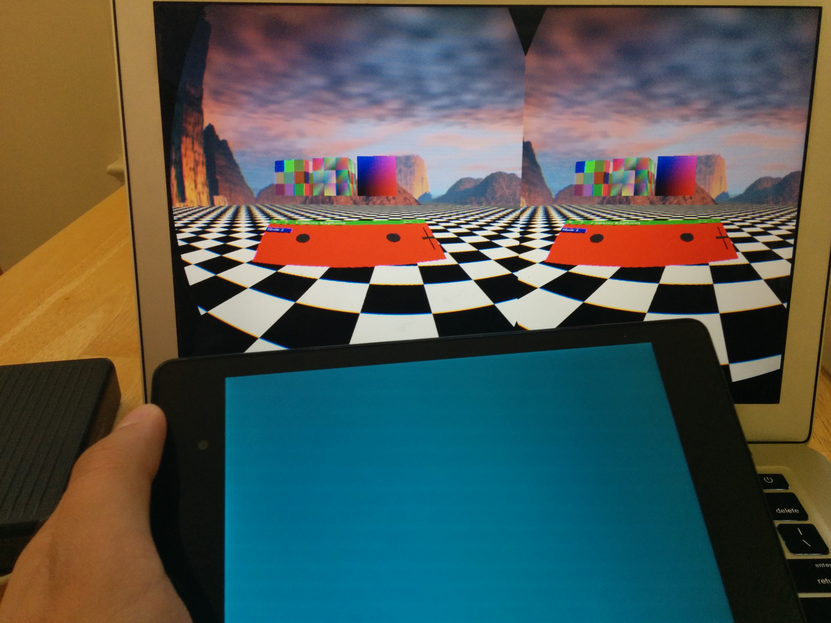
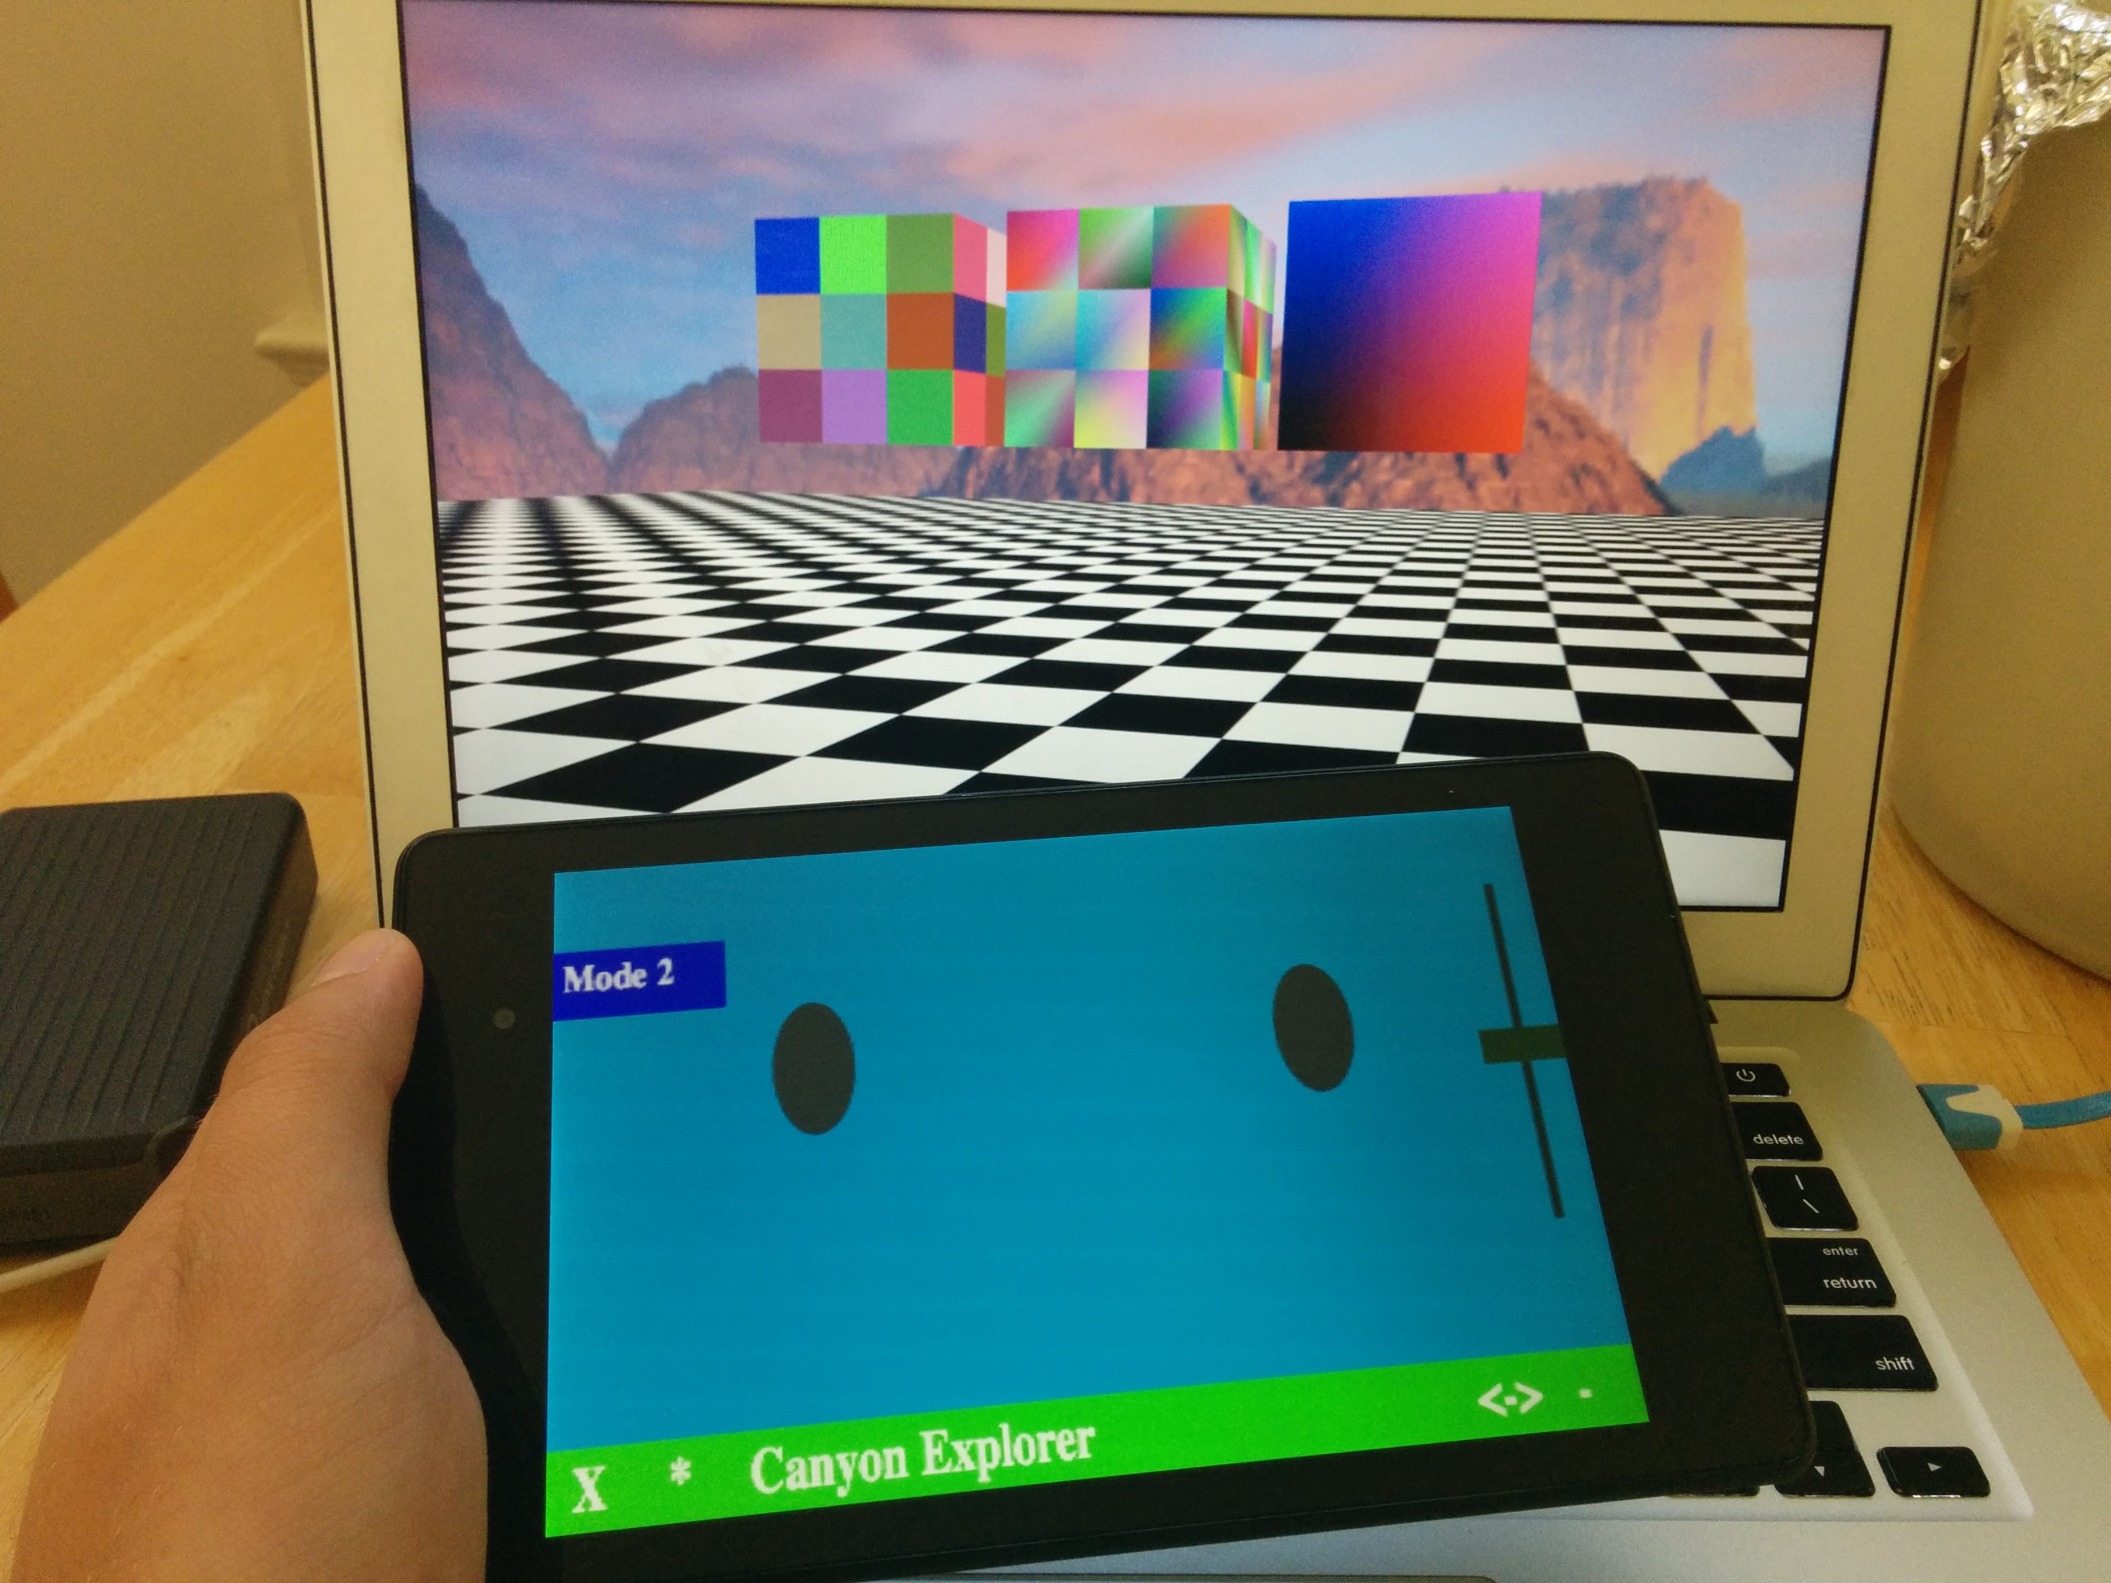
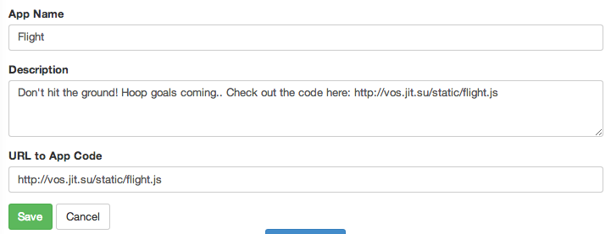
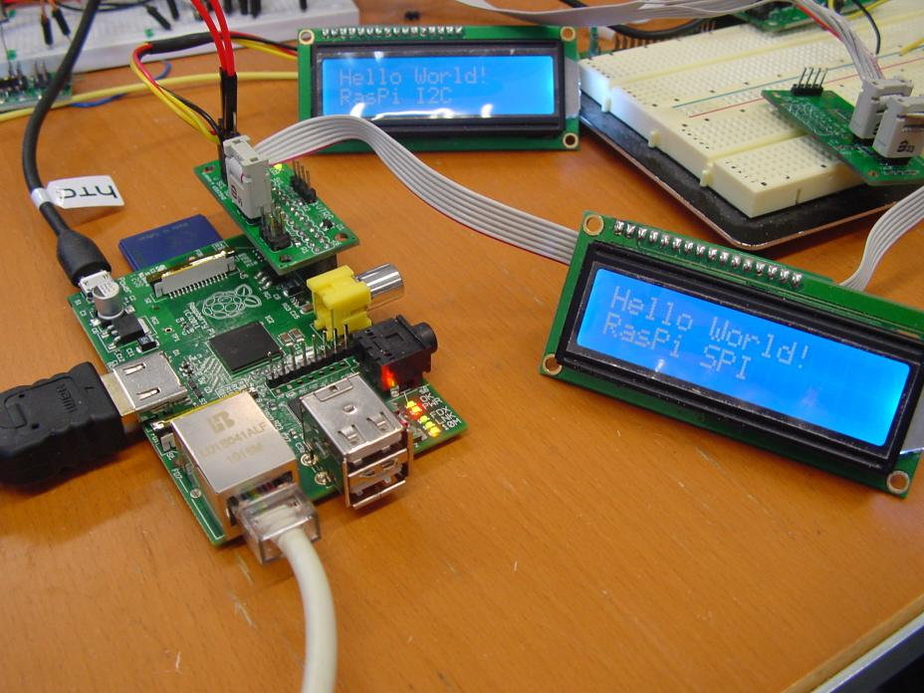
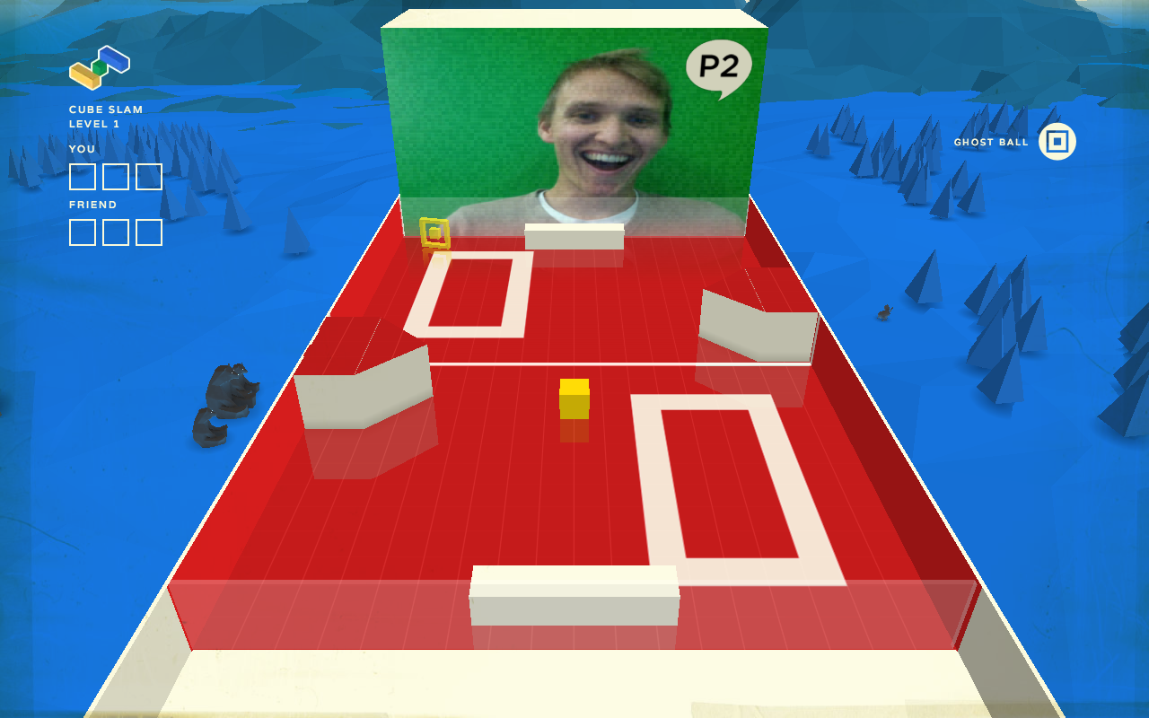


slider.onMove(function(y) {
cube.phi = Math.PI*(y-0.5);
});
slider = new Controls. LinearSlider(0,0,4,1,{
returnToCenter: false
});
app.panel.add(slider);
Without HUD
With HUD
Image: Example Rasp. Pi with LCD
vOS experience could be simplified into a “vOS box” Raspberry Pi computer browser to stream to Oculus Rift.

Ports:
HDMI out to Oculus Rift
Audio out to headset
Microphone in to browser
USB in for head tracking
Power for Raspberry Pi
LCD for pair code to a tablet.
Goal: “Magic School Bus” style education

A teacher could guide a group of students
through the time of dinosaurs or the surface
of the Moon regardless of student’s locations.

- Students could learn in inspirational environments with minimal distractions
- Teachers could easily look back on students’ activities.
- Virtual reality tests would be nearly impossible to cheat on.

Multi-person collaboration possible through web sockets, WebRTC

Image: CubeSlam’s use of WebRTC + WebGL
Apps are hosted on third party servers
Source registered for search and preview

Works with or without heads up display

